Murti, Radhika (from ANU Alumni Notes April 2015)
1 April 2015
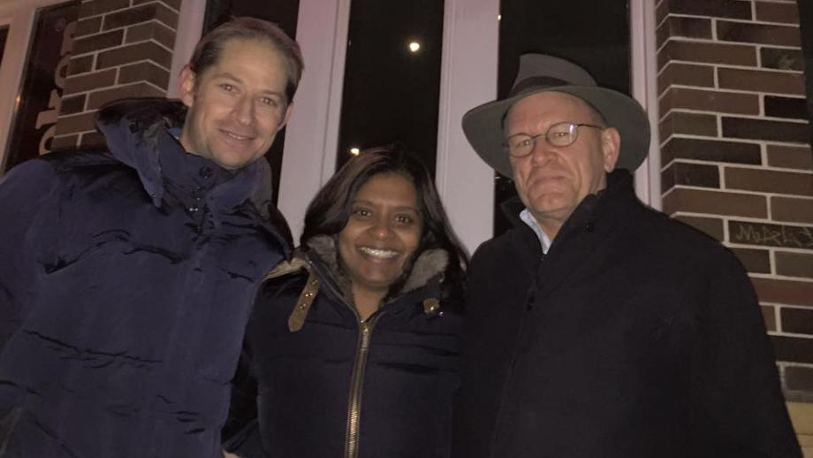
Rob McWIlliam, Radhika Murti and Peter Kanowski
Radhika Murti (BSc (Forestry) (Hons) '03 & Robert McWilliam BSc (Forestry) (Hons) '03 bumped into Master of University House, and Professor of Forestry in the Fenner School of Environment & Society Peter Kanowski (BSc (Forestry) (Hons) '82) at their local pub in Gland, Switzerland (pictured). Radhika and Robert met at ANU and are now married. Robert works for The Forest Trust and is working with small and large businesses around the world to establish and implement strong procurement policies that eliminate deforestation and respect people and the environment. Radhika is working in Disaster Risk Reduction for the International Union for Conservation of Nature. Radhika recently delivered a speech at the UN World Conference on Disaster Risk Reduction in Japan, and did a TED talk on disaster risk reduction.

